压测详细报告
生成时间：2025-11-12 16:49:19

摘要
总请求数：10000 成功：10000 失败：0 成功率：100.00%
总耗时(秒)：493.44 平均吞吐(req/s)：20.27

响应时间统计 (ms)
最小：2995.07 最大：8979.18 平均：4966.85
P50：4861.56 P90：5892.74 P95：6121.15 P99：7008.39

状态码分布
200: 10000

错误汇总
无错误记录

latency_hist
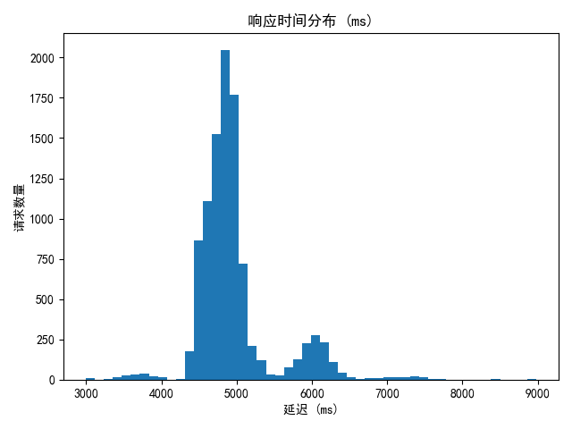

rps
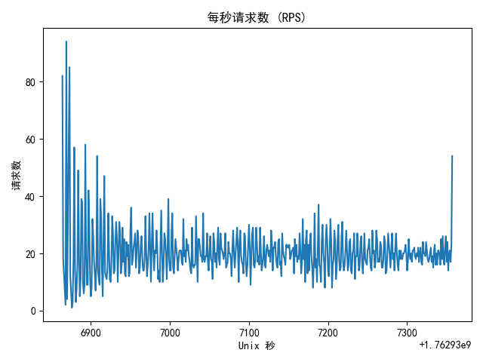

请求明细（前100条）
# | 时间 | 状态码 | 延迟(ms) | 响应大小 | 错误
27 | 2025-11-12 16:41:04 | 200 | 4316.097021102905 | 12
17 | 2025-11-12 16:41:04 | 200 | 4503.03053855896 | 12
5 | 2025-11-12 16:41:04 | 200 | 4509.0272426605225 | 12
2 | 2025-11-12 16:41:04 | 200 | 4527.026891708374 | 12
1 | 2025-11-12 16:41:04 | 200 | 4531.03494644165 | 12
3 | 2025-11-12 16:41:04 | 200 | 4544.030666351318 | 12
11 | 2025-11-12 16:41:04 | 200 | 4560.0340366363525 | 12
13 | 2025-11-12 16:41:04 | 200 | 4577.026128768921 | 12
33 | 2025-11-12 16:41:04 | 200 | 4572.026252746582 | 12
4 | 2025-11-12 16:41:04 | 200 | 4583.027601242065 | 12
32 | 2025-11-12 16:41:04 | 200 | 4583.027601242065 | 12
22 | 2025-11-12 16:41:04 | 200 | 4594.027280807495 | 12
10 | 2025-11-12 16:41:04 | 200 | 4599.024772644043 | 12
21 | 2025-11-12 16:41:04 | 200 | 4595.026016235352 | 12
36 | 2025-11-12 16:41:04 | 200 | 4610.026121139526 | 12
15 | 2025-11-12 16:41:04 | 200 | 4618.0260181427 | 12
9 | 2025-11-12 16:41:04 | 200 | 4621.026039123535 | 12
14 | 2025-11-12 16:41:04 | 200 | 4631.024599075317 | 12
20 | 2025-11-12 16:41:04 | 200 | 4631.0272216796875 | 12
12 | 2025-11-12 16:41:04 | 200 | 4634.026288986206 | 12
49 | 2025-11-12 16:41:04 | 200 | 4622.025966644287 | 12
38 | 2025-11-12 16:41:04 | 200 | 4627.026319503784 | 12
24 | 2025-11-12 16:41:04 | 200 | 4633.0246925354 | 12
69 | 2025-11-12 16:41:04 | 200 | 4627.023458480835 | 12
19 | 2025-11-12 16:41:04 | 200 | 4649.024724960327 | 12
79 | 2025-11-12 16:41:04 | 200 | 4632.027387619019 | 12
7 | 2025-11-12 16:41:04 | 200 | 4659.02853012085 | 12
6 | 2025-11-12 16:41:04 | 200 | 4660.027503967285 | 12
47 | 2025-11-12 16:41:04 | 200 | 4647.025108337402 | 12
25 | 2025-11-12 16:41:04 | 200 | 4673.023462295532 | 12
81 | 2025-11-12 16:41:04 | 200 | 4654.026746749878 | 12
8 | 2025-11-12 16:41:04 | 200 | 4681.026220321655 | 12
18 | 2025-11-12 16:41:04 | 200 | 4678.02619934082 | 12
16 | 2025-11-12 16:41:04 | 200 | 4683.026075363159 | 12
34 | 2025-11-12 16:41:04 | 200 | 4680.025339126587 | 12
77 | 2025-11-12 16:41:04 | 200 | 4667.027473449707 | 12
63 | 2025-11-12 16:41:04 | 200 | 4682.023763656616 | 12
70 | 2025-11-12 16:41:04 | 200 | 4683.023452758789 | 12
67 | 2025-11-12 16:41:04 | 200 | 4687.023401260376 | 12
23 | 2025-11-12 16:41:04 | 200 | 4703.025102615356 | 12
92 | 2025-11-12 16:41:04 | 200 | 4689.024209976196 | 12
87 | 2025-11-12 16:41:04 | 200 | 4696.024417877197 | 12
56 | 2025-11-12 16:41:04 | 200 | 4708.02640914917 | 12
65 | 2025-11-12 16:41:04 | 200 | 4705.023765563965 | 12
68 | 2025-11-12 16:41:04 | 200 | 4705.024003982544 | 12
43 | 2025-11-12 16:41:04 | 200 | 4729.025363922119 | 12
64 | 2025-11-12 16:41:04 | 200 | 4725.023984909058 | 12
85 | 2025-11-12 16:41:04 | 200 | 4727.025270462036 | 12
58 | 2025-11-12 16:41:04 | 200 | 4738.027095794678 | 12
90 | 2025-11-12 16:41:04 | 200 | 4748.024463653564 | 12
28 | 2025-11-12 16:41:04 | 200 | 4771.021842956543 | 12
46 | 2025-11-12 16:41:04 | 200 | 4764.024019241333 | 12
26 | 2025-11-12 16:41:04 | 200 | 4787.028789520264 | 12
88 | 2025-11-12 16:41:04 | 200 | 4770.025014877319 | 12
35 | 2025-11-12 16:41:04 | 200 | 4790.027618408203 | 12
82 | 2025-11-12 16:41:04 | 200 | 4774.026393890381 | 12
50 | 2025-11-12 16:41:04 | 200 | 4788.024663925171 | 12
31 | 2025-11-12 16:41:04 | 200 | 4805.024862289429 | 12
73 | 2025-11-12 16:41:04 | 200 | 4792.027235031128 | 12
80 | 2025-11-12 16:41:04 | 200 | 4795.027494430542 | 12
94 | 2025-11-12 16:41:04 | 200 | 4790.027618408203 | 12
44 | 2025-11-12 16:41:04 | 200 | 4809.029340744019 | 12
48 | 2025-11-12 16:41:04 | 200 | 4815.025806427002 | 12
71 | 2025-11-12 16:41:04 | 200 | 4809.027433395386 | 12
72 | 2025-11-12 16:41:04 | 200 | 4810.025930404663 | 12
42 | 2025-11-12 16:41:04 | 200 | 4829.024314880371 | 12
78 | 2025-11-12 16:41:04 | 200 | 4818.0272579193115 | 12
57 | 2025-11-12 16:41:04 | 200 | 4826.025724411011 | 12
61 | 2025-11-12 16:41:04 | 200 | 4828.025341033936 | 12
41 | 2025-11-12 16:41:04 | 200 | 4837.023496627808 | 12
52 | 2025-11-12 16:41:04 | 200 | 4845.023393630981 | 12
29 | 2025-11-12 16:41:04 | 200 | 4854.026794433594 | 12
30 | 2025-11-12 16:41:04 | 200 | 4857.025146484375 | 12
84 | 2025-11-12 16:41:04 | 200 | 4839.025497436523 | 12
37 | 2025-11-12 16:41:04 | 200 | 4856.026649475098 | 12
59 | 2025-11-12 16:41:04 | 200 | 4863.027334213257 | 12
60 | 2025-11-12 16:41:04 | 200 | 4864.0265464782715 | 12
93 | 2025-11-12 16:41:04 | 200 | 4853.025436401367 | 12
54 | 2025-11-12 16:41:04 | 200 | 4870.025157928467 | 12
75 | 2025-11-12 16:41:04 | 200 | 4864.025831222534 | 12
89 | 2025-11-12 16:41:04 | 200 | 4860.024690628052 | 12
97 | 2025-11-12 16:41:04 | 200 | 4859.026193618774 | 12
86 | 2025-11-12 16:41:05 | 200 | 4870.026350021362 | 12
96 | 2025-11-12 16:41:05 | 200 | 4868.025541305542 | 12
53 | 2025-11-12 16:41:05 | 200 | 4886.023998260498 | 12
98 | 2025-11-12 16:41:05 | 200 | 4877.027273178101 | 12
51 | 2025-11-12 16:41:05 | 200 | 4895.024061203003 | 12
74 | 2025-11-12 16:41:05 | 200 | 4888.025999069214 | 12
100 | 2025-11-12 16:41:05 | 200 | 4882.0250034332275 | 12
99 | 2025-11-12 16:41:05 | 200 | 4882.0250034332275 | 12
39 | 2025-11-12 16:41:05 | 200 | 4905.02667427063 | 12
55 | 2025-11-12 16:41:05 | 200 | 4910.027503967285 | 12
91 | 2025-11-12 16:41:05 | 200 | 4905.026197433472 | 12
62 | 2025-11-12 16:41:05 | 200 | 4927.027463912964 | 12
83 | 2025-11-12 16:41:05 | 200 | 4921.027183532715 | 12
76 | 2025-11-12 16:41:05 | 200 | 4948.025703430176 | 12
45 | 2025-11-12 16:41:05 | 200 | 4999.026536941528 | 12
95 | 2025-11-12 16:41:05 | 200 | 5127.027750015259 | 12
66 | 2025-11-12 16:41:05 | 200 | 5412.693023681641 | 12
40 | 2025-11-12 16:41:05 | 200 | 5575.217962265015 | 12

